Using Carausel to Make testimonials in the websites
1st: Copy code from getbootstrap.com/docs/4.5,
copy carausal code type “with indicator”


- Remove all <li/> from <ol> together <ol> from the top of code ok. Due to it we can remove “dashes like in the pic”.

- To align carausal image in the center remove “d-block” and “w-100” apply less widht like “w-60” etc. From the class specified in the <img/> tag.

- Remove class="carousel-control-next" and class="carousel-control-prev" from <a/> anchor tag exist in below like -
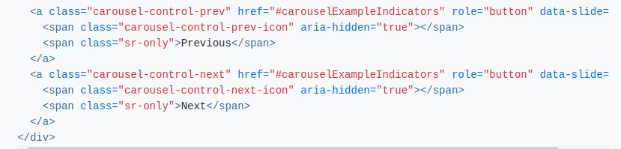

- By Removing This Help us to move indidators at the bottom of testimonial card some thing like this
- here in the testimonail card a background color are set so you can use a class attribute inside the <div> tag of card ok see below, look div containing pre-defined class name “carousel-inner” act a main div that responsible to hold all testimonial cards, so I have, used “testimonial-card-container” by itself to apply background color in it.

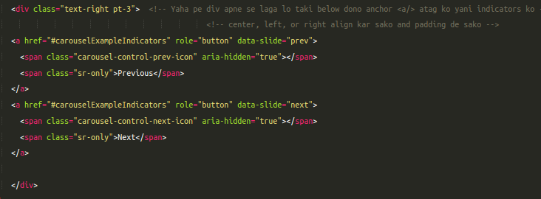
- Put both anchor <a/> tag inside a container element div so that you can proper align the indicators and apply padding for space. Look in the pic

Now You have successfully Built Testimonial Using Bootstrap Carausel.

Date: 3-March-2025

